Task no 1
EDA and Visualization of a Real-World Dataset
Step by Step performance of EDA and Visualization on real world Dataset taking Titanic Dataset as example.
Step 1:
- Load the Dataset: Use Pandas to load and explore the dataset
INPUT:
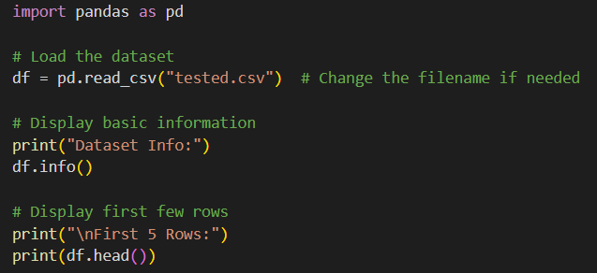
OUTPUT: 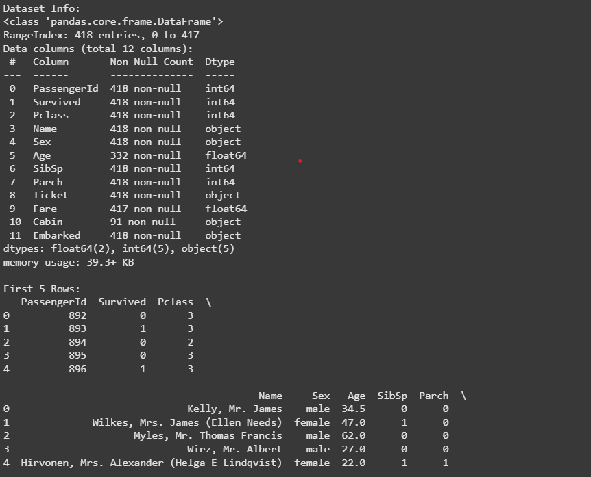
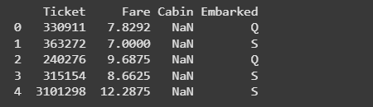
- Data Cleaning: Handle missing values using imputation techniques or removal
INPUT:
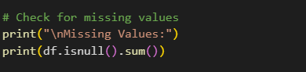
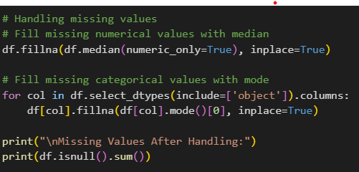
OUTPUT:
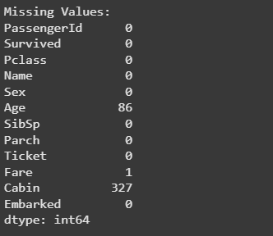
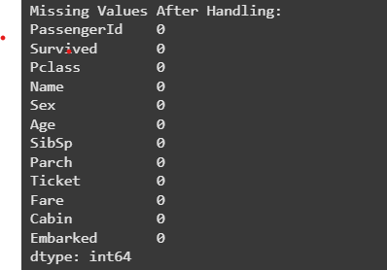
- Remove duplicates.
INPUT:
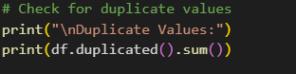
OUTPUT:
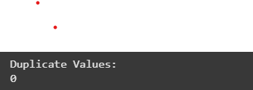
- Identify and manage outliers using statistical methods or visualization.
INPUT:
Identifying the outliers
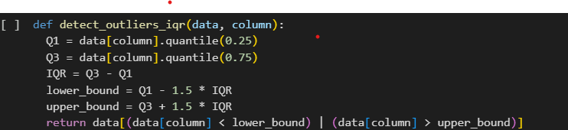
OUTPUT:
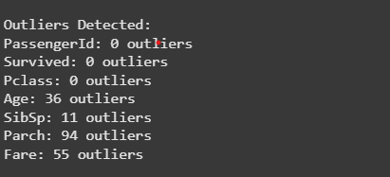

Managing the outliers
INPUT:
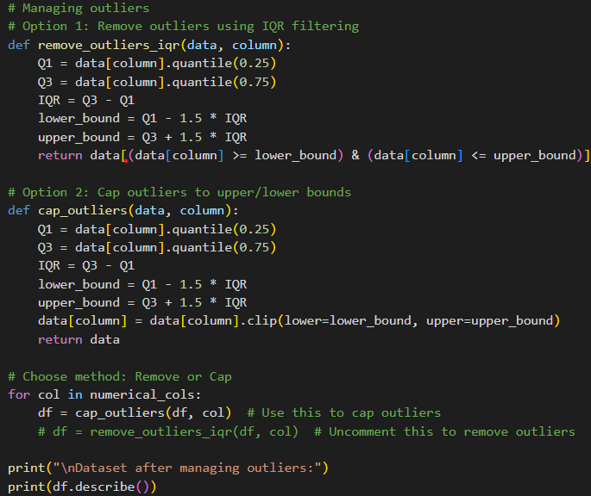
OUTPUT:
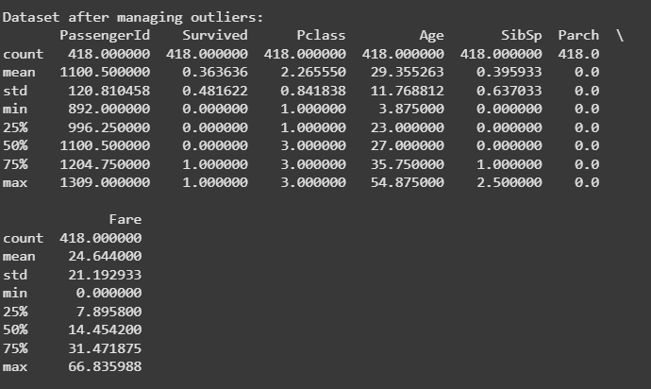
Visualizations:
  - Create bar charts for categorical variables.
INPUT:
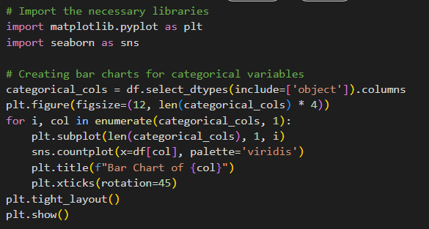
OUTPUT:
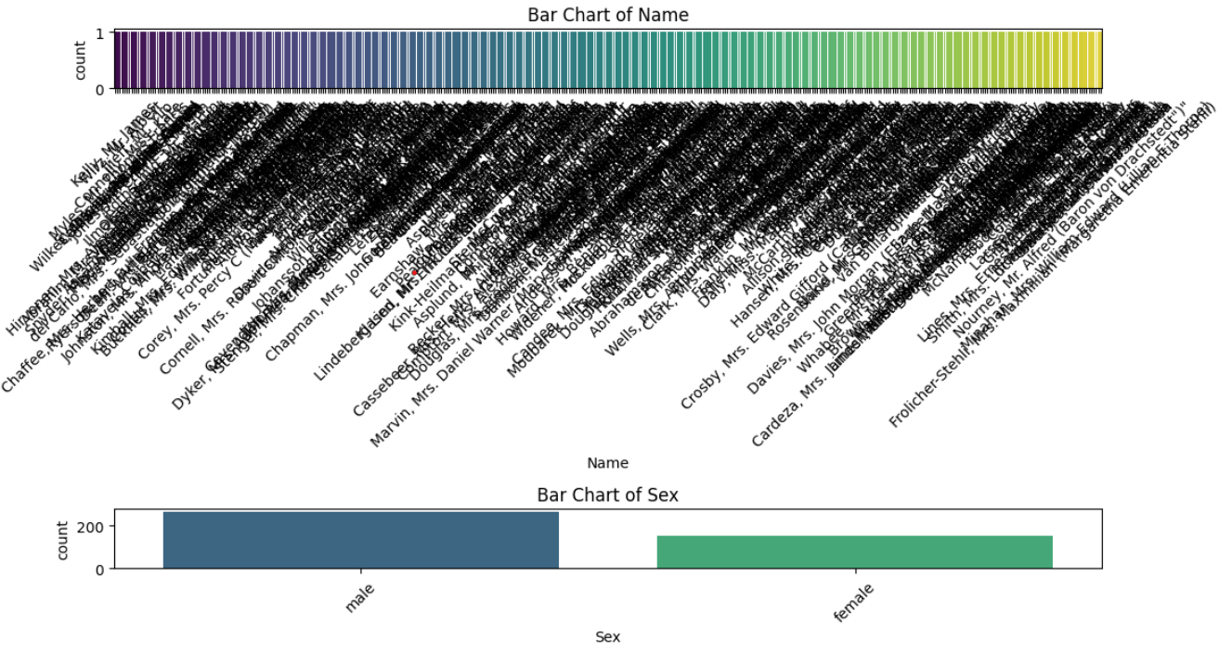
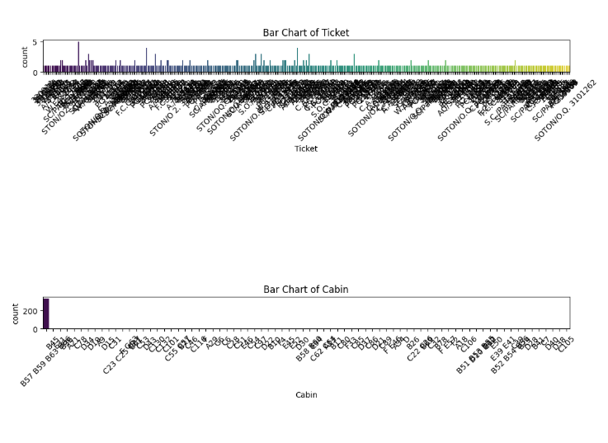
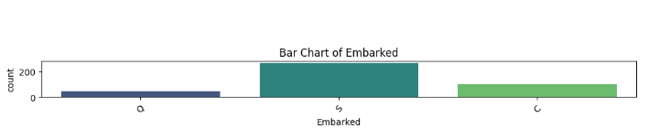

- PLOT HISTOGRAMS FOR NUMERIC DISTRIBUTIONS
INPUT:
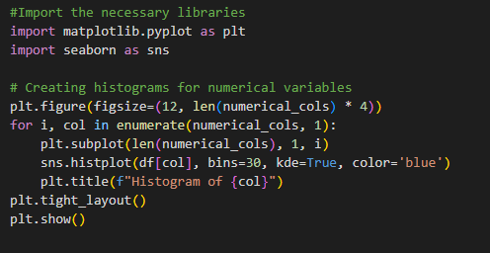
OUTPUT:
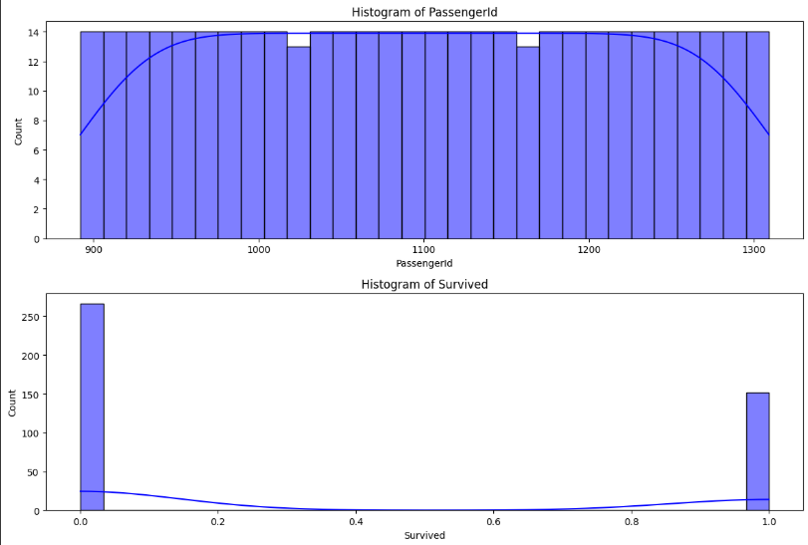
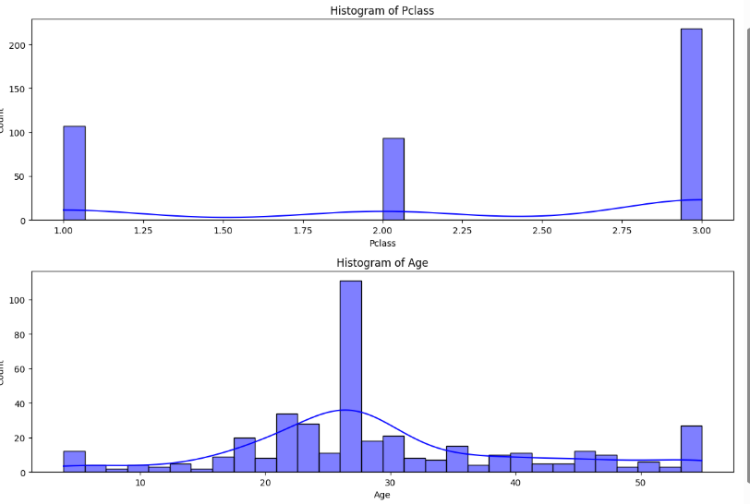
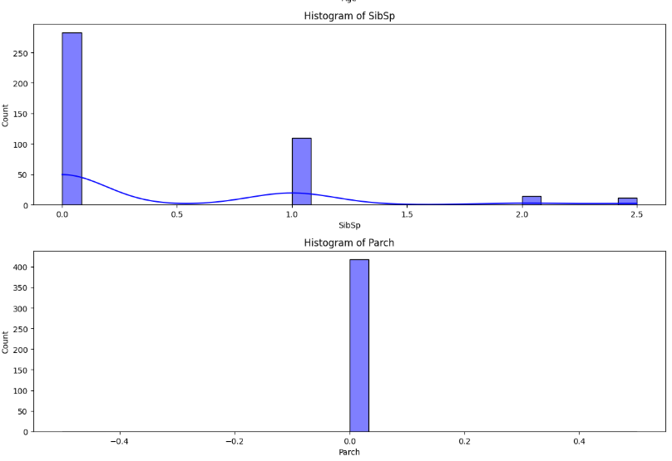
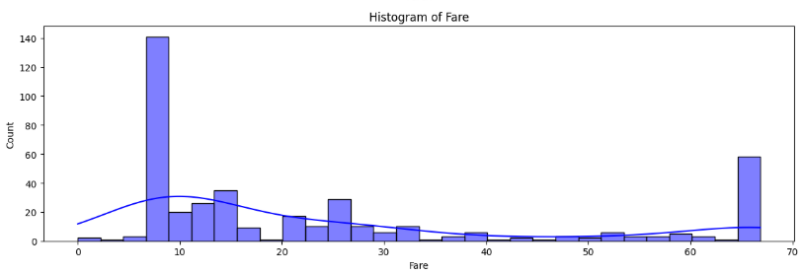
- Generate a correlation heatmap for numeric features
INPUT:
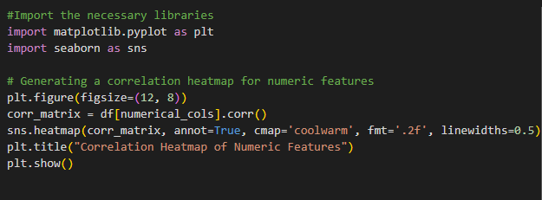
OUTPUT:
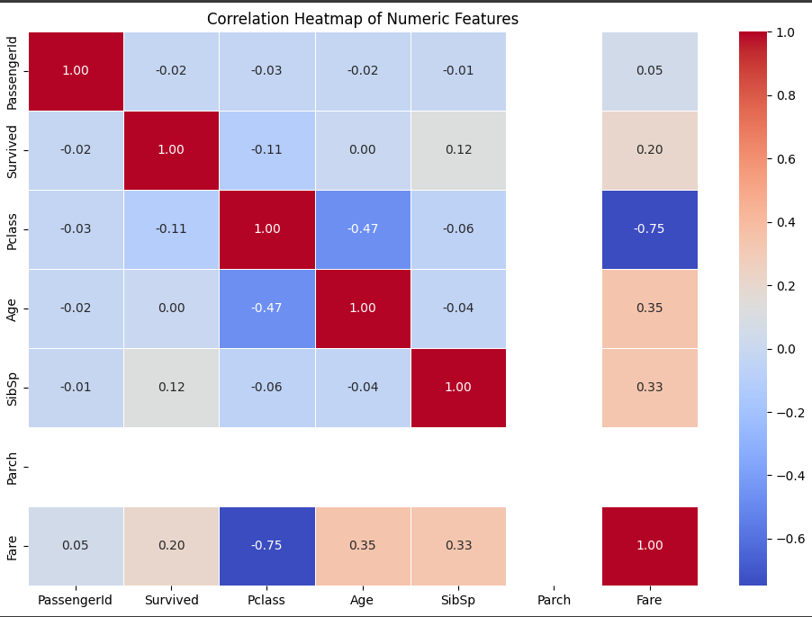
Task No 2
Build a sentiment analysis model using a dataset such as IMDB Reviews
Step 1:
- Text Preprocessing: Tokenize Text into individual words.
INPUT:

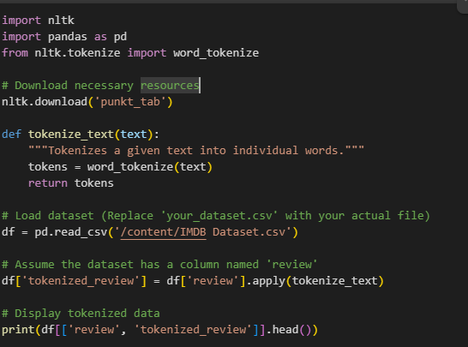
OUTPUT:
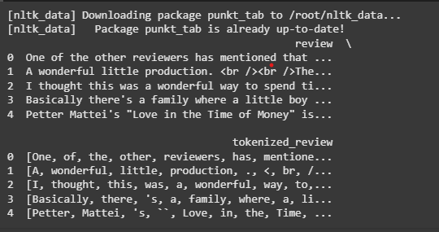
- Remove stopwords.
- Perform lemmatization for text normalization.
- Convert text data into numerical format using TF-IDF or word embeddings
- Train a classifier such as Logistic Regression or Naïve Bayes to predict sentiment
- Evaluate the model’s performance using metrices like precision, recall, and F1-score.
INPUT:
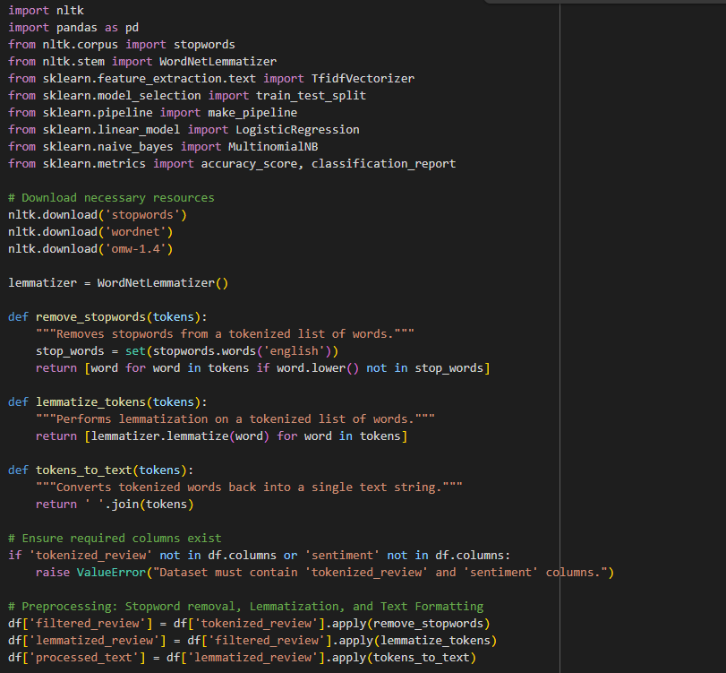
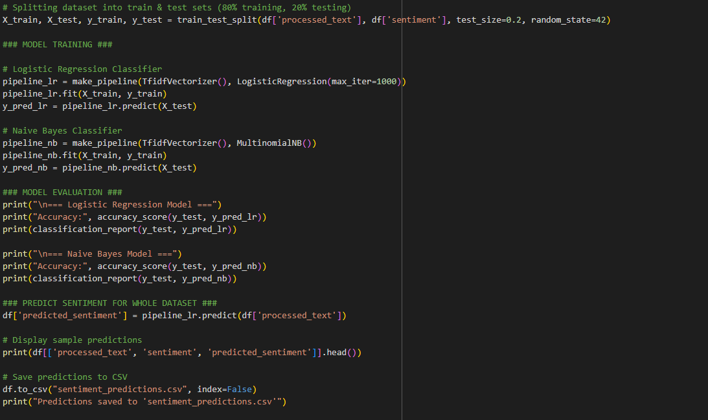
INPUT:
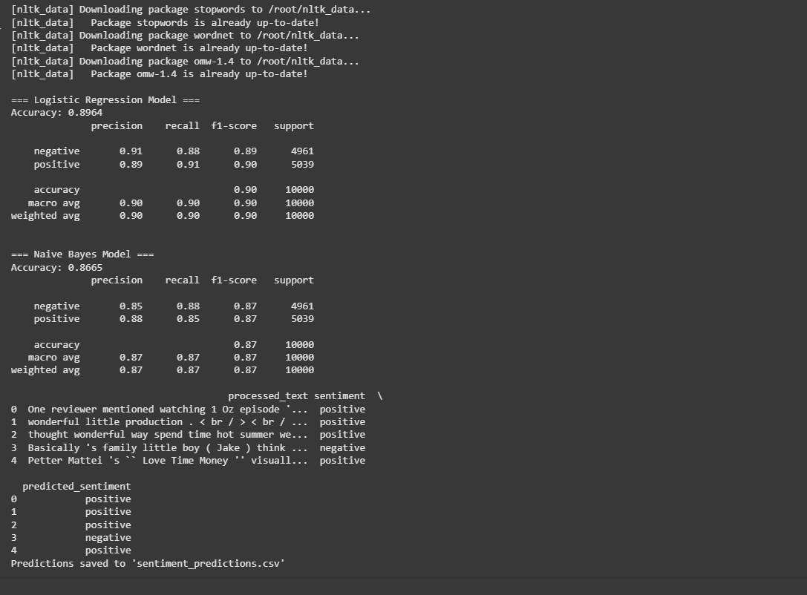
Task No 3
Fraud Detection System
Description:
Develop a fraud detection system using a dataset like the Credit Card Fraud Dataset.

Steps:
- Data Preprocessing:
  - Handle imbalanced data using techniques like SMOTE or undersampling.
INPUT:
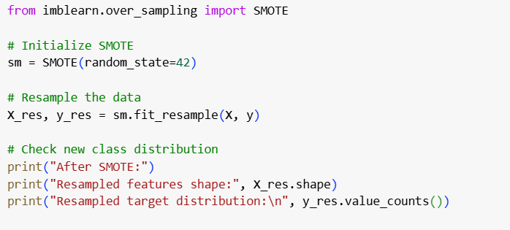
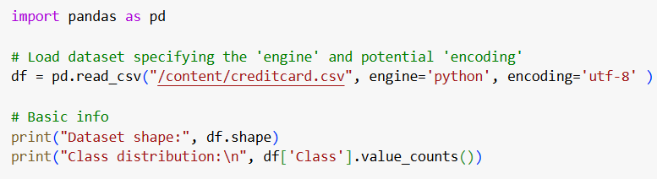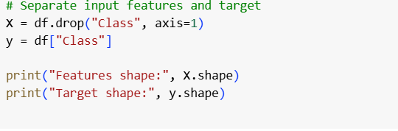

OUTPUT:
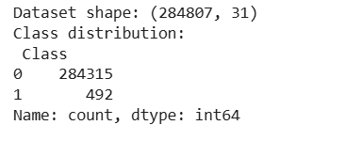
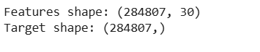
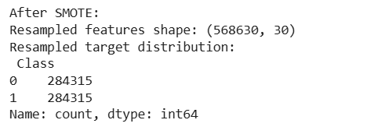
- Model Training:
- Train a Random Forest or Gradient Boosting model to detect Fraudulent transactions.
INPUT:
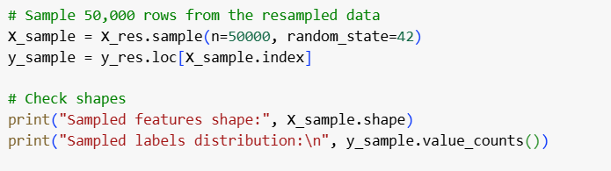
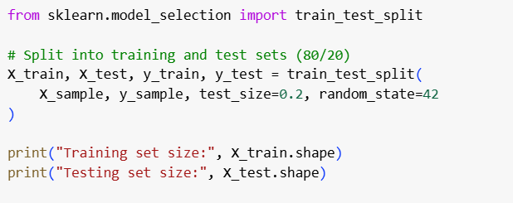
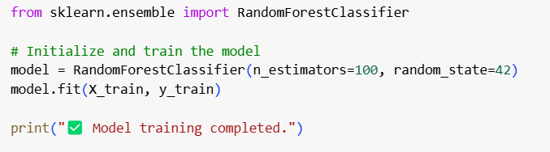
OUTPUT:
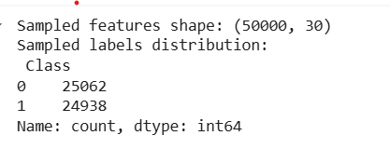
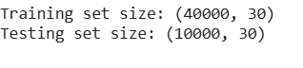
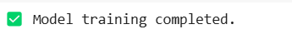
- Testing Interface:
- Create a simple interface (e.g., a command-line input) to test the fraud detection system.
INPUT:
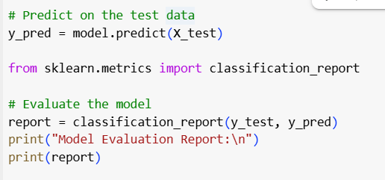
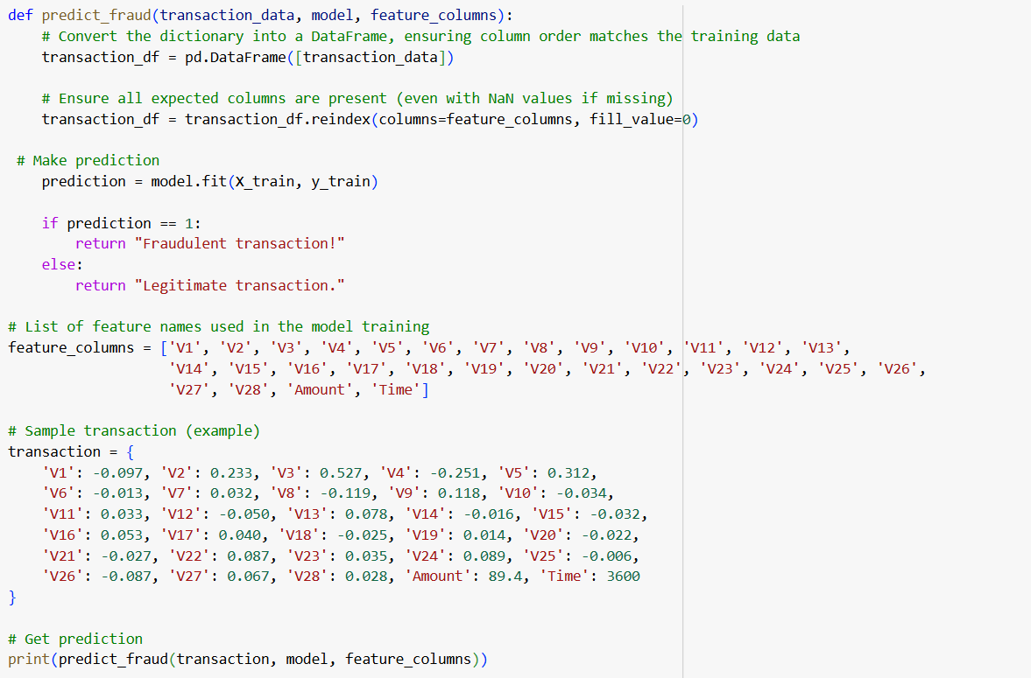
OUTPUT:
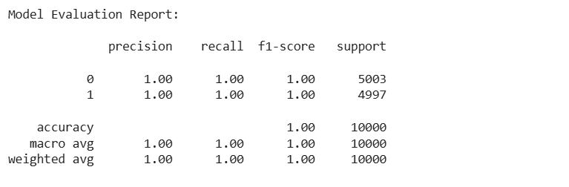
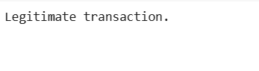 Task No 4
Predicting House Prices Using the Boston Housing Dataset

Description:
Build a regression model from scratch to predict house prices using the Boston Housing Dataset.

Steps:
- Data Preprocessing:
Normalize numerical features and preprocess categorical variables
INPUT:
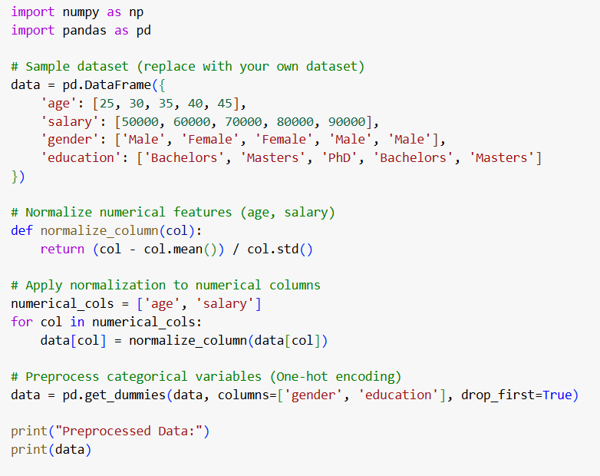
OUTPUT:
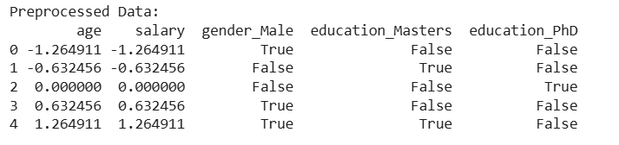
- Model Implementation:
- Implement Linear Regression, Random Forest, and XGBoost models from scratch (avoid using built-in libraries like sklearn.linear_model).
- INPUT
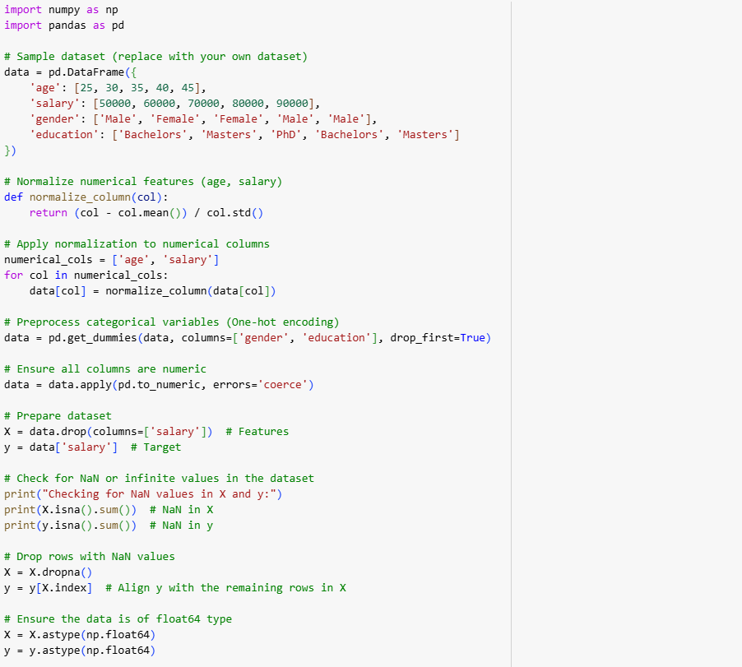
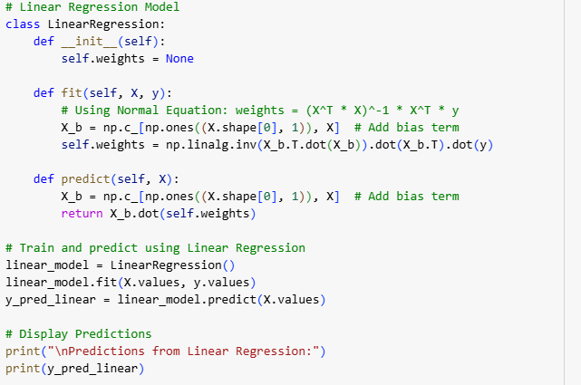
OUTPUT:
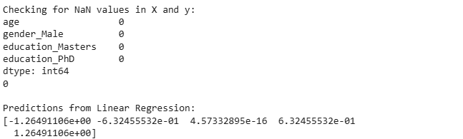
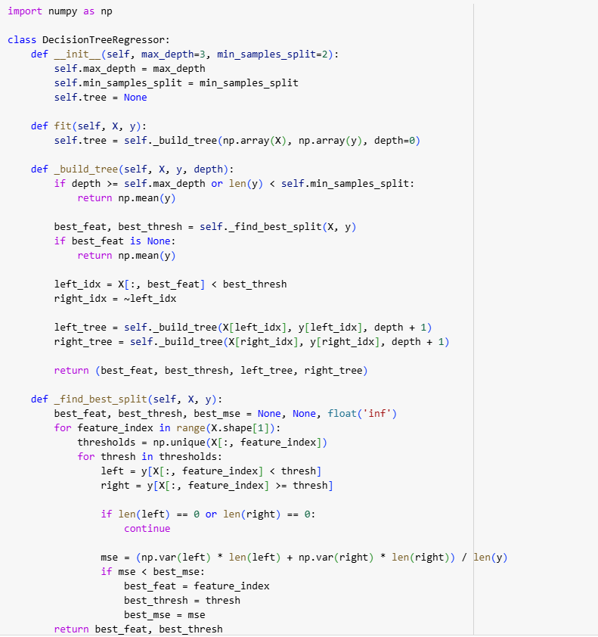
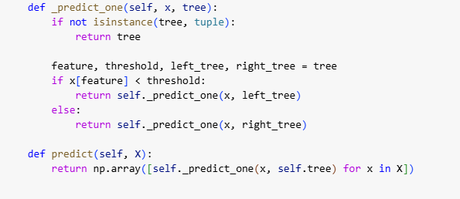
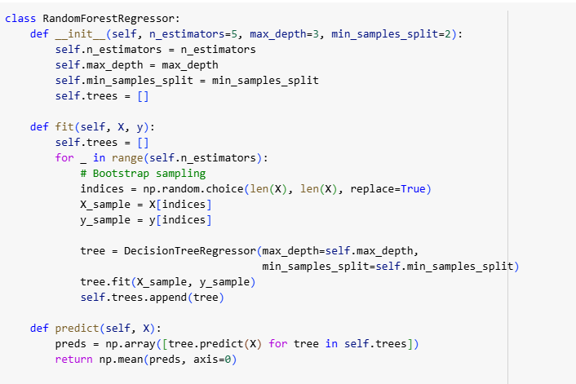
OUTPUT
- Performance Comparison:
  - Compare the models using RMSE and R² metrics
INPUT:
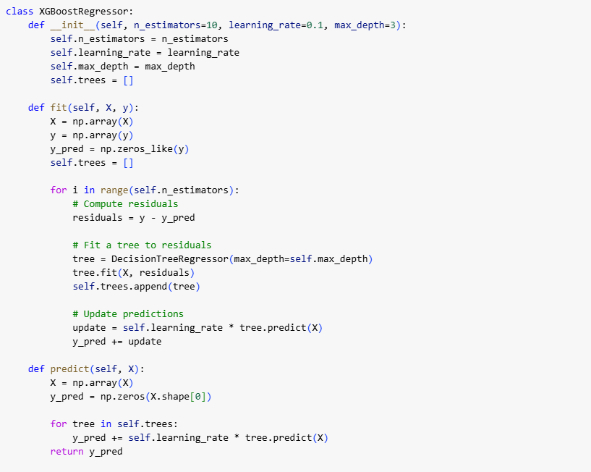
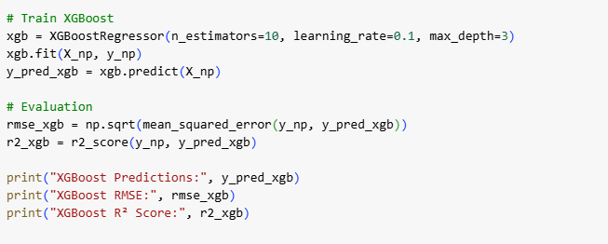
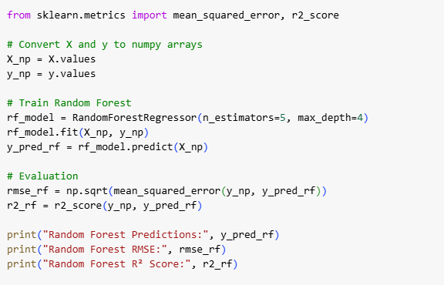
INPUT:
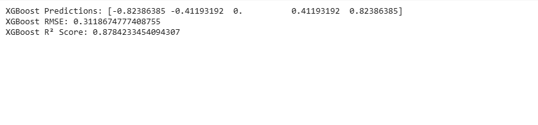

- Feature Importance:
  - Visualize feature importance for tree-based models.
INPUT:
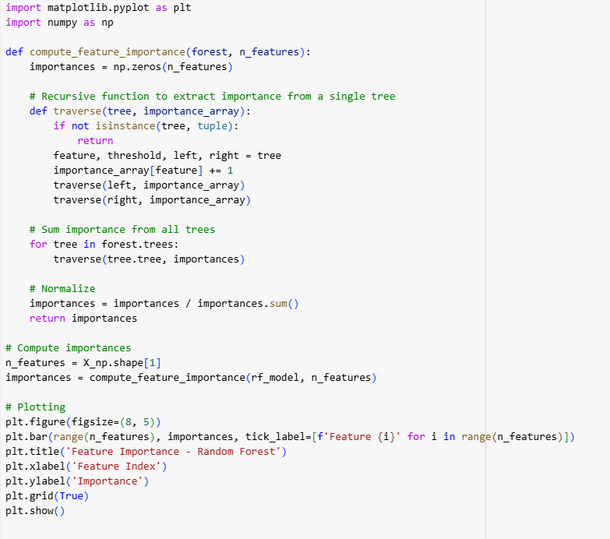
OUTPUT:
